Monument lettering is available in
many styles.
Lettering techniques vary according to the stone finish and type of carving applied to the rest of the monument. Many of the most popular lettering techniques are shown here.
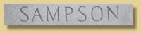Sunk (V-Sunk) Sandblasted In Steeled Finish (Modified Roman)

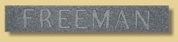Frosted Outline (Double Outline) Letters in Polish (Sans Serif/Optima)

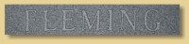Frosted Outline (Double Outline) Letters in Polish (Modified Roman)

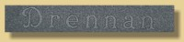Frosted Outline (Double Outline) Letters in Polish (Custom Font/Hand-Drawn)

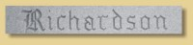Sunk (V-Sunk) Sandblasted In Steeled Finish (Old English)

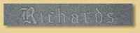Frosted Outline (Double Outline) Letters in Polish (Old English)

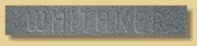Sunk (Sandblasted) Into Polish (Vermarco)

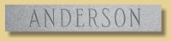Sunk (V-Sunk) Sandblasted In Steeled Finish (Condensed Modified Roman)

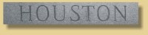Sunk (V-Sunk) Sandblasted In Steeled Finish (Modified Roman)

